THIRD PARTY LOGISTICS COORDINATOR – REVERSAL PICK PACK TO GRN

Engineer submit the spare return form .

Then return receipt will be generated and assigned to the respective logistics coordinator

Logistics coordinator do the following steps

URL- <https://mcis.deltaiserve.net/>

1)Type the URL , enter the login credential and do the login

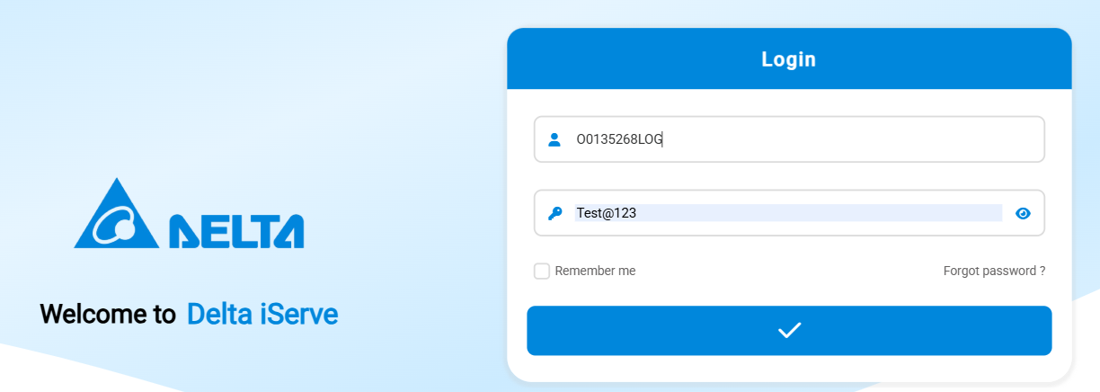

GO TO INVENTORY receipt module and see the assigned receipt

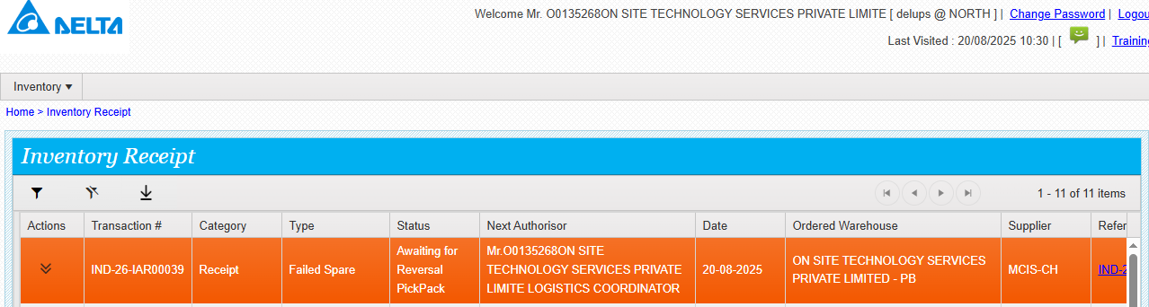

Click on reversal pick pack

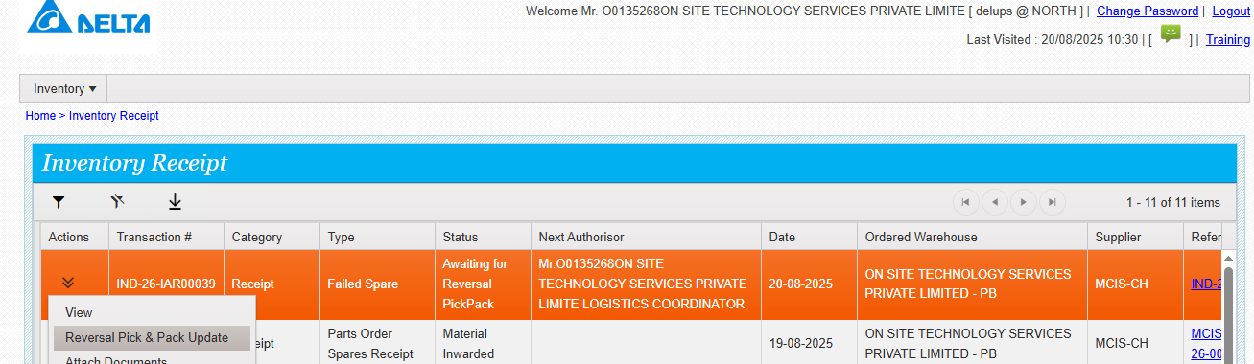

Fill the required details and submit

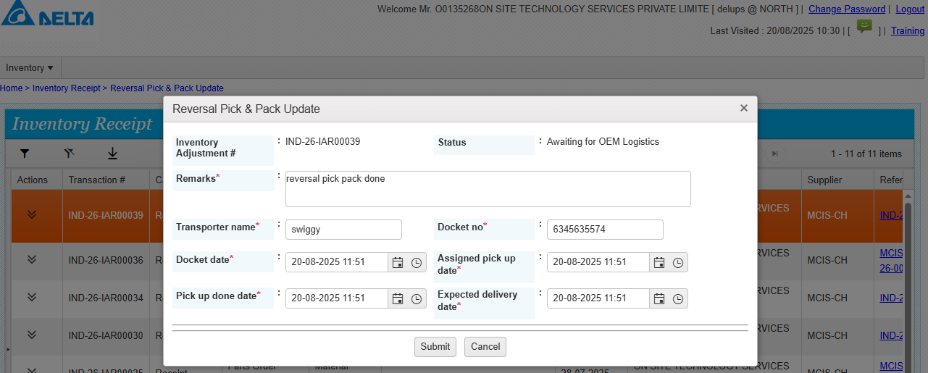

Reversal pick pack done

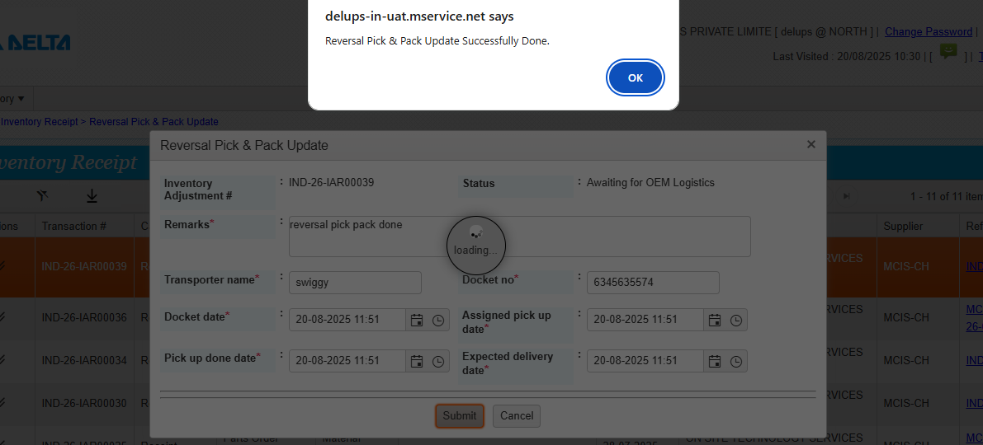

Now the status of the receipt is awaiting for delivery update 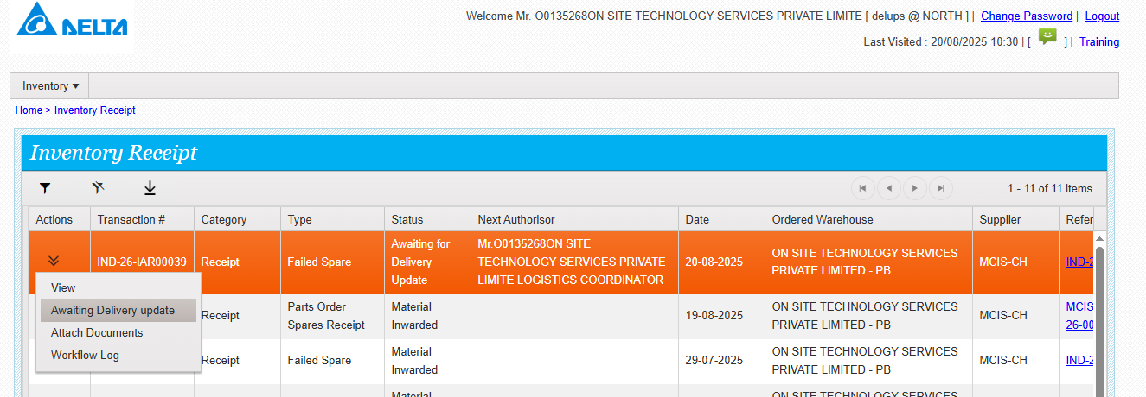

Go to action and click on delivery update .fill the required details and submit

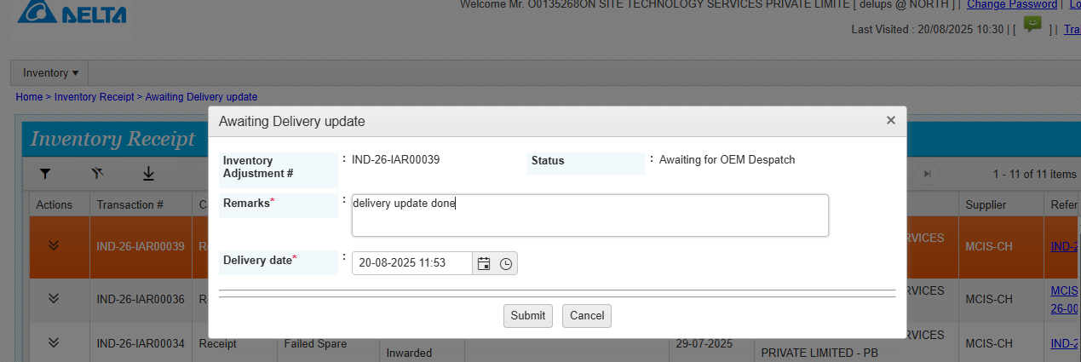

Delivery update done successfully.

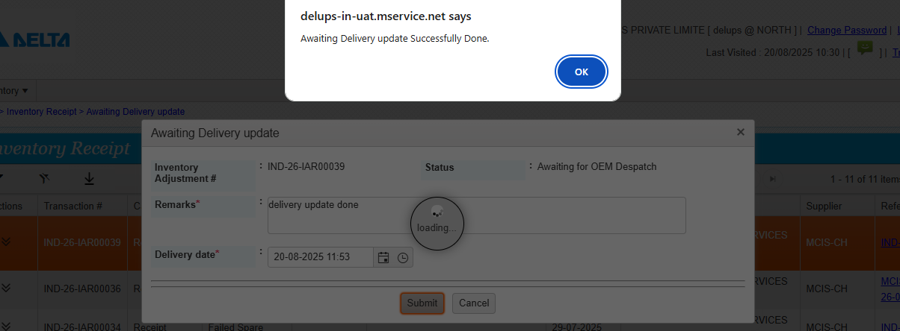

Now the status is awaiting GRN

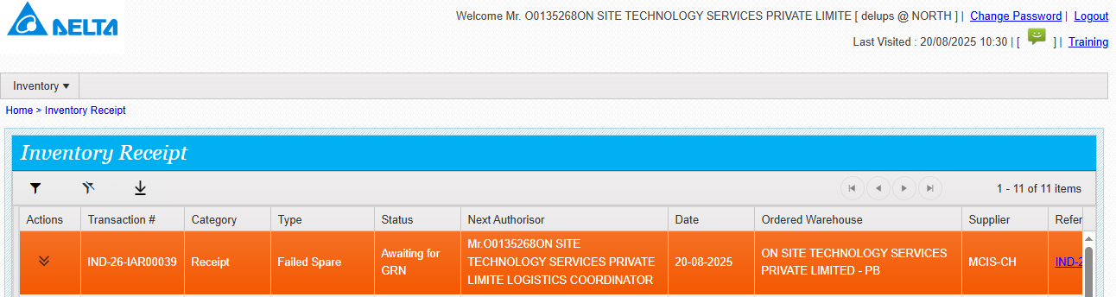

Go to action and click on GRN update / input columns are editable , 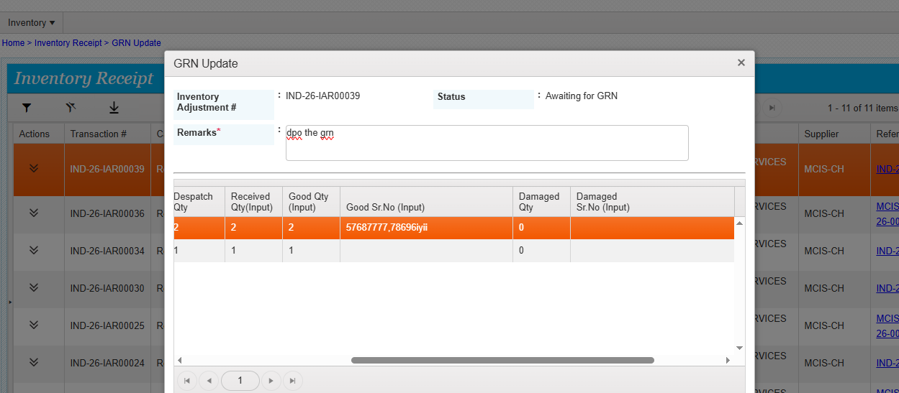

Provide the input and submit

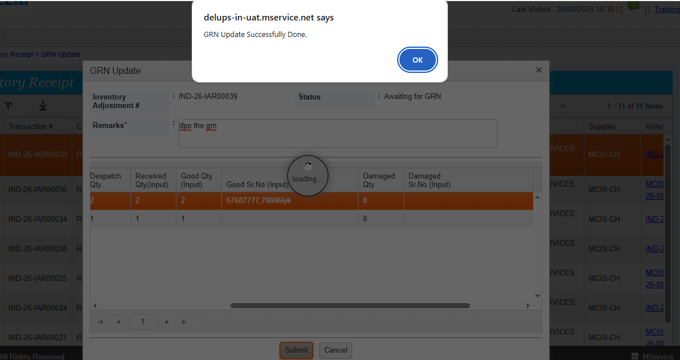

Failed parts inward done successfully.